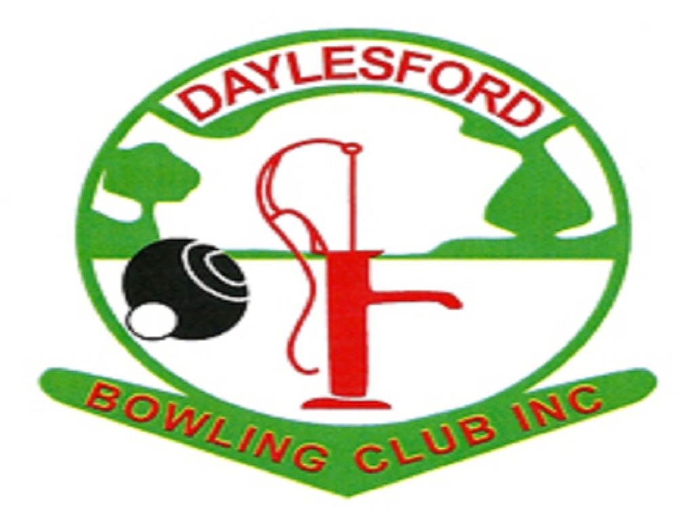

DAYLESFORD BOWLING CLUB INC.

8 CAMP STREET, DAYLESFORD

MONTHLY OPEN FOURS 2022/23
Proudly Sponsored by


$60 PER TEAM
11am START – Lunch & afternoon tea included

1st 4 x $50.00
2nd 4 x $20.00

TOURNAMENT DATES
October 19th, November 16th, December 21st,
January 18th, February 15th, March 15th

ENTRIES TO

Tournament Director
Winston Silbereisen - 0409428019
Or phone Daylesford Bowling Club on - 53482130
Email: info@daylesfordbowlingclub.com.au

